|  |  |
| --- | --- |
| Assessor: | T. Mkwaira |
| Moderator: | - |

# Web Programming 27(8)1: Self-directed assessment

## INSTRUCTIONS: GENERAL

* This a self-directed exercise for personal assessment. It will not be marked.

## INSTRUCTIONS: SUBMITTING YOUR TEST

* You will not submit this assessment.

## INSTRUCTIONS: INTEGRITY AND LIABILITY

* **Integrity**: Observe the Honor Code1. Each candidate is expected to maintain academic integrity.

## INSTRUCTIONS: FORMAT OF THE ASSESSMENT

* This assessment includes T/F questions.
* Encapsulate all your logic inside functions.
* Create a separate file for each of the tasks. This could also be an HTML page with embedded JavaScript.
* The allocated time includes time for uploading/ saving your solution.

# Complete the following tasks:

## Task 1: [15 Marks]

You can use any of JavaScript’s inbuilt methods for this task, and there is no limit to the approach, e.g., a requirement to use functions.

* Create a JavaScript file and declare two arrays at the beginning. The first array is *fruit* and must contain any 3 fruit elements. Call the second array *vegetables* and it must contain any 3 vegetable elements.[2]
* Display the length of the *vegetable* array in the console. [1]
* Put the two arrays together into one array, *fruit* first. Call the new array *food*. You can use the array method called join or do it using a loop.[2]
* Remove the last 2 elements from your new array. [2]
* Reverse your *food* array. You could use an inbuilt method or do it manually. [2]
* Remove only the first element in *food*. [2]

## Task 2: [15 Marks (11 + 4 bonus)]

Create a user-input based application that performs some calculations on two numbers based on the chosen operation.

**Note**:

* The form has been provided, however note that none of the elements have been given an ID. Do not assume that the form does not have any other important information. I encourage you to test. You are welcome to create your own form if you wish, but you would have to match the styling.
* You should validate the input from the user. Remember that a user may provide a value which is not entirely made of numbers, or they may give input nothing at all. You are welcome to use input type = number for the relevant inputs.
* The answer should appear in the div that appears at the bottom. You can write a value by using:

document.getElementById(“id_of_output_div”).innerHTML = yourAnswer

* The form may need some additional attributes, for example if you want to use an ID to create objects that represent your elements.
* For bonus marks: [4]
  + *Change the colour of the text in the answer div to red if there is an error and green otherwise.*
  + *In the output, you should show what the calculation was, for example 1+3 = 4*

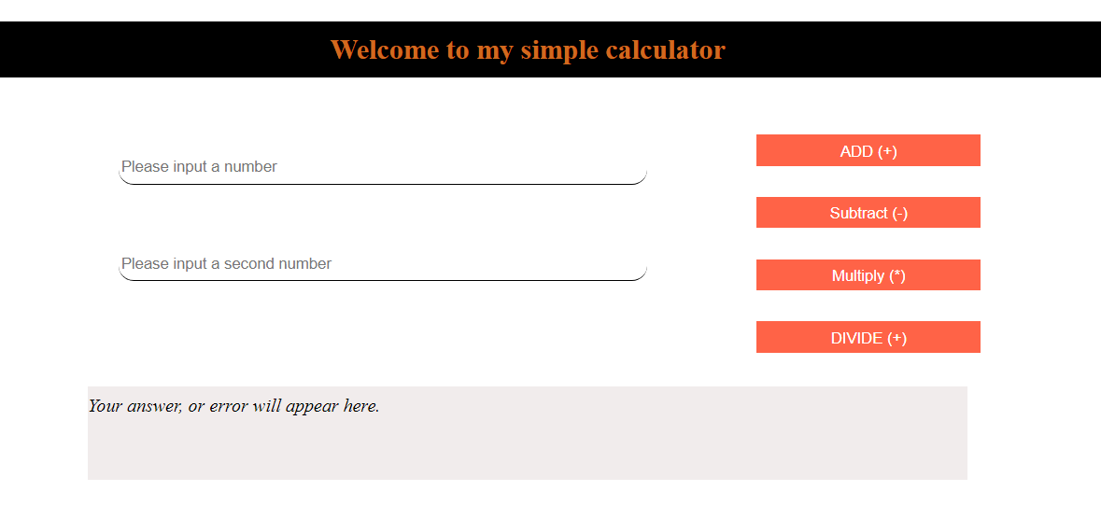

*.*

## Task 3: [max 25 Marks]

Here is code that generates a random number in a range given by min and max.

const random = (min, max) => Math.floor(Math.random() * (max - min)) + min;

* Create a function that returns 10 random numbers between 1023 and 3201. [2]
* Create a second function that returns 10 random *but unique* numbers between 3201 and 1023. [2]
* Change all the numbers into strings by mapping through them with the JS *map* function (or forEach etc.), and by using string concatenation.

You must encapsulate this logic in a function and return an array. [2]

* How many values in the new array of strings end with the value 2? Use a function to return the answer.[2]
* Change the code so that you can ask the user for input. [5]
* How would you give the user feedback depending on their input? [3]
* Can you think of another way to provide the answers to a user by using the document as an input/ output modality? [5]

# How to Submit: ZIP ONLY! ZIP ONLY!

## Naming Convention

You must submit a **ZIP** file that uses the Campus standard naming convention. Any assessment that a student creates for electronic submission must conform to the following naming convention:

*WPR27(8)1 CT2_StudentSurname_StudentName.zip*

The reason for this is to ensure that your assessment is received correctly by your lecturer; this prevents any inconvenience for you as the student and the lecturer.

## Packaging your solution

1. Create a folder that follows the naming convention explained above.
2. Move the Tasks folder into the named folder you created in Step 1.
3. Finally, create a **zip** archive of the folder you created in Step 2.
4. Upload your zip archive.